1. **DEFINITIONS:**
   1. **Construction/Maintenance Contractor** – Any Contractor engaged in activities such as constructing, erecting, installing, repairing, demolishing, remodeling, or similar activity.

***(Level “A” Contractor******Requirements)***

* 1. **Technical/Process Service Contractor** – Any Contractor engaged in activities such as inspection, equipment servicing, calibration, process control, industrial cleaning, environmental sampling, engineering, etc. where Contractor employees could be in direct contact with the manufacturing process or equipment. ***(Level “B” Contractor Requirements)***
  2. **Administrative/Support Service Contractor** – Any Contractor engaged in activities such as security, fire protection maintenance, janitorial services, etc. where Contractor employees would be in a Facility,but not in direct contact with any process or equipment. ***(Level “B” Contractor Requirements)***
  3. **Vendor -** Provides services without the use of tools. Examples include stocking tools/supplies/PPE, water delivery service, laundry service, consultants.

1. **RECOMMENDATIONS:**

We recommend you review the following with each of your employees:

* 1. Do not take pictures in our facility without prior authorization and review.
  2. Do not talk on cell phones while driving or operating any equipment.
  3. Violations of the aforementioned rules will result in device confiscation.
  4. ATI does not permit foreign nationals (non-United States citizens) on site without a full time company (ATI) escort. We will not issue a contractor badge to foreign nationals from any country.
  5. Do not post anything including photos on any social media sites regarding ATI or while onsite at an ATI plant.

1. **PPE:**

All contractor employees must have the following basic PPE to enter our facility:

* 1. **Safety glasses** with side shields (foam lined are recommended, but not required).
  2. **Hard Hats;** Place stickers in hard hats indicating the first service date. Replace hard hats every 5 years from the date of first service. Hard hats are required when welding and grinding.
  3. **Steel Toed Safety Shoes** **with metatarsal guards** meeting ANSI Standard Z41-1991.
  4. **Additional job specific PPE** based on the work you are performing. It is the contractor’s responsibility to provide required PPE to their employees. (Note: Contractors may purchase their safety equipment through Mallory Co at ATI’s special pricing by contacting Mallory Co Customer Service at 360-690-8200).

1. All contractor employees are required to have some form of company logo on their clothing or hardhat clearly identifying the company for which they work. The contractor’s employee must be identifiable from a distance of 50 feet or beyond. ATI recommends standardizing to same color hard hats or providing company shirts/uniforms/vests.
2. The maximum speed limit in our plant is 15 MPH with several areas posted less than this.
3. The back road is not for through traffic; only use this road if your project area is in either the Sand Chlorination or the Separations departments.
4. Due to the amount of ongoing construction activities taking place in our facility, parking is extremely limited. ATI will not allow personal contractor vehicles to go through the gates. Vehicles entering the plant must have a clearly visible company logo **adhered to both driver and passenger side doors**.
5. Transport employees from the gate to job site in a vehicle containing approved seat belts for each passenger.
6. Wear seat belts when operating a motor vehicle or any piece of industrial mobile equipment.
7. **All** products used on our plant site require approval prior to their use. Maintain SDS sheets at all times for each product brought on site in a binder kept at the job site.
8. Secure project sites at the end of each day leaving them in a safe condition. Remove all remaining project materials, debris, contractor trailers and toolboxes immediately at the conclusion of a project.
9. **Job Trailers Policy:**

* Job trailers are evaluated on a per job basis
* Remove job trailer from ATI facilities as soon as work is complete
* The Project Engineer, Operations Department and Contractor will determine the necessity of a job trailer during the pre-activity meeting.

1. For **Level ‘A’** contractor, each badged employee is expected to have a current CSTOP© card (valid for 2 years). ATI will not activate individual badges without this. Verification of your badge holders CSTOP status will eliminate delays during badge activation.

***C STOP Training is available on-line at cstop.org or contact Guy O’Tierney at 425-822-8300 or via email at*** [Admin@c-stop.org](mailto:Admin@c-stop.org)

**Badges:**

* We recommend companies maintain control of badges and issue to their employees as needed to perform work at ATI’s facilities.
* Contractors are responsible to return badges of dismissed personnel or personnel laid off for a prolonged period.
* Failure to adhere to these recommendations may affect the timely payment of invoices.
* Lost and found badges should be reported to the Contractors Program desk immediately. **If a replacement badge is required, a $20.00 replacement fee will be charged.**

**New Employee Badges-** All new contractor employees must make an appointment with [ATIcontractor.program@ATImaterials.com](mailto:ATIcontractor.program@ATImaterials.com) to complete the badging process. Training is provided and scheduled on Tuesday and Thursday. Email us for an appointment.

Badging process includes the following:

* View and Complete on-site specific training video *(1 hour Millersburg and Albany Ops/34th locations)*
* Photo badge processing
* US Citizenship required
* Current Valid Government issued ID required
* Proof of C STOP training completion *(Copy of Completion Certificate/Card)* Level “A” Contractors ONLY
* Read/Complete/Sign ATI Non-Disclosure Form

1. **Safety Audit Inspections:**

Plant Engineering performs random weekly safety audit inspections on job sites. These audits help enforce safe practices within the plant. Examples of items audited are below.

* + PPE requirements
  + SDS sheets at the job site
  + Pre-Activity form at the job site
  + Hard hat date of service stickers
  + Contractor identification (company logo on person)
  + Safety Training/Certification Cards
  + Emergency action plan posted at job site and understood by employees in accordance with OSHA (*see example*)

1. **Components of an Emergency Action Plan:**
   * Emergency Escape Procedures & Escape route assignments
   * Procedures to be followed by employees who remain to operate emergency equipment
   * Procedures to account for all employees after emergency evacuation is complete
   * Rescue and medical duties for responsible employees
   * The preferred means of reporting fires and other emergencies
   * Names and regular job titles of person or department to contact for further information or explanation of duties under the plan
   * Alarm system
   * Evacuation types
   * Records of Initial Training when EAP was developed and annual refresher training
   * Written plan at every job site and specific to the job
2. All contractors are required to have an in house safety program beyond the basics of C STOP in which each contractor employee conducts safety training and testing. This documentation must be saved and verifiable at any time. Specific training requirements may vary by contractor and will be evaluated on a case by case basis based on the contractor’s scope of work and hazards involved. Periodic refresher courses must be conducted for the contractor’s personnel. The program must be clearly defined and cover topics such as and not limited to the following.
   * Confined space: attendant, entry, supervisor
   * Crane Safety: flagging, signaling, rigging, Load charts,
   * Fall Protection: equipment, anchor points, hazard assessment
   * Fire Safety/Prevention: fire suppression equipment, exit routes, medical services
   * Forklift Training: snorkel boom lift, warehouse lift, scissor lift
   * Hazard Assessment: Evaluation for hazard
   * Hazard communication (Haz-com)
   * PPE: eye, face, respiratory, head, hand, foot, hearing
   * Scaffolding Safety: erecting, modifying, suspended
   * Emergency Response: rescue training, fire and evaluation, first aid
   * Lockout Try Out (LOTO)

***NOTE: OSHA NOW OFFERS FREE FALL PROTECTION TRAINING -***

***Employers and workers who engage in construction activities in Oregon now have a free and flexible way to improve their understanding of fall protection, thanks to an online video training course produced by Oregon OSHA. The following link below will take you to the “Fall Protection for Construction” training class.***

[**https://osha.oregon.gov/news/2020/Pages/nr2020-31.aspx**](https://osha.oregon.gov/news/2020/Pages/nr2020-31.aspx)

1. As a company, ATI continues to set higher safety standards for our employees. These higher expectations require contractors to be proactive in your approach to safety. One indicator used to measure the effectiveness of your safety program is the Experience Modification Rate (EMR) provided to your company by your Worker’s Compensation carrier. The EMR is an important indicator that rates your safety performance within the Standard Industrial Classification (SIC) of others in your line of work. An EMR of 1.0 is average, less than 1.0 is below the average rate of injury. We expect our contractors to be committed to a safety program producing an EMR of less than 1.0. Those companies whose EMR is above the average, and trending upwards over three consecutive years or who have a single year EMR above 1.3 are subject to possible suspension from future work until the EMR is reduced to an acceptable level.
2. You must complete a Pre-Activity Check List with your ATI contact person prior to any badge activation. Keep a copy of this Pre- Activity Check list at the job site as your authorization to perform work. **Only your ATI contact person is authorized to request badge activation**
3. **Job Site Binder:** All Level “A” contractors will have a well-organized job site binder with the following sections (not necessarily in listed order)

* Pre-Activity Form
* Safety Instructions (SI’s necessary for job and mentioned in Pre- Activity Form)
* Contractor Employee Matrix
* Applicable SDS sheets
* Emergency Action Plan
* IBMS Policy

1. **Safety Instruction List:** Below is a list of the current SI’s. (*Electronic versions attached in email*).

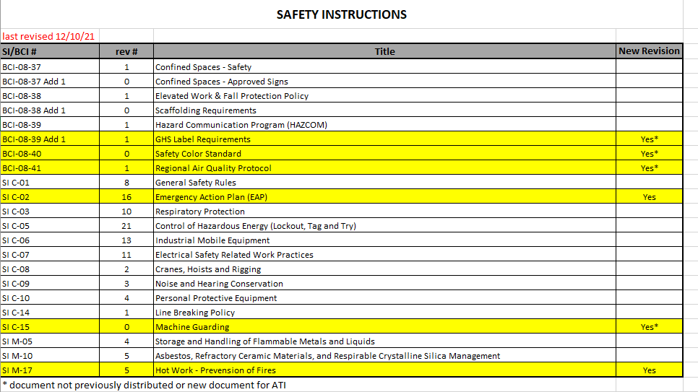

1. **Integrated Business Management System (IBMS) Policy:**
   * We are committed to continually improving our integrated business management system and processes, while managing risk and meeting all applicable compliance obligations
   * Our responsibility is to protect our employees, customers, assets, and the environment, while providing products and services of the highest quality consistent with customers and other requirements.
2. As a company, ATI reserves the right to request a search of personal effects from employees, visitors, contractors and vendors upon entering or leaving Company property, and at any time while on Company property or on Company business, without prior announcement. At such times, vehicles, briefcases, purses, lunch boxes, tool boxes, containers, etc., will be subject to inspection. (WI-PS-014, Rev 0)

If you have any questions concerning our contractor safety program, contact the ATI Contractor Program desk in Plant Engineering at (541) 926-4211, x6107 or email us at [ATIcontractor.program@ATImaterials.com](mailto:ATIcontractor.program@ATImaterials.com)

ATI Contractor Program Team

* Kimberly Hahn - Program Assistant
* Kim Garza - Program Administrator
* James Raber - Program Back-Up
* Luke Walden - Program Manager